

SOFTWARE REQUIREMENT SPECIFICATION REPORT FOR THE SUPPLY, DELIVERY, INSTALLATION, TESTING, COMMISSIONING AND MAINTENANCE OF AN CASE MANAGEMENT SYSTEM (CMS)

(FRAMEWORK CONTRACT)

January 16, 2023

SUBMITTED BY:



Digital Imaging & Scanning International Ltd

**(DISI GROUP CONFIDENTIAL**

Introduction

Purpose

Scope

Definitions, Acronyms, and Abbreviations

References

Overview

General Description

Product Perspective

Product Features

User Characteristics

Constraints

Assumptions and Dependencies

Specific Requirements

Functional Requirements

Authentication and Authorization:

Case Management:

Case Parties Profiling:

Court Profile:

Management Tracking of Files Movement:

Administration of Legal Fees:

Reports:

Non-Functional Requirements

External Interface Requirements

Design Constraints

The system is designed for use in a legal environment and is not intended for use in other industries.

The system's functionality is based on a set of assumptions about the legal process and may not be suitable for use in jurisdictions with different legal processes.

The system is not intended to provide legal advice and should not be used as a substitute for the advice of a qualified legal professional.

Appendices

Glossary

Use Case Diagrams

Activity Diagrams

Sequence Diagrams

Class Diagrams

System Architecture Diagrams

## Introduction

### Purpose

The purpose of this Software Requirements Specification (SRS) document is to describe the requirements for the development of a Case Management System. The system is designed to streamline the process of managing legal cases by providing a centralized platform for case management and case-related data. The system shall allow users to create, manage, and view cases, track the movement of case files, and administer legal fees. The system shall also provide predefined reports and data visualization features to enable users to interpret data easily.

### Scope

The Case Management System is a web-based application that allows authorized users to create, manage, and view legal cases and related data. The system shall provide authentication and authorization features to ensure that only authorized users have access to the system and that they can only perform actions that they are authorized to perform. The system shall also provide features for creating and managing case profiles, case party’s profiles, court profiles, and tracking the movement of case files within the court system. In addition, the system shall allow for the administration of legal fees and provide predefined reports and data visualization features to enable users to interpret data easily.

### Definitions, Acronyms, and Abbreviations

Definitions:

* Case: A legal matter or dispute that is being managed by the system.
* Case profile: A detailed record of a case, including information such as the parties involved, case status, and court location.
* Legal fees: The fees charged by advocates and magistrates for their legal services in relation to a case.
* File movement tracking: The ability to track the physical location and status of case files within the court system.
* Custom report: A report generated by the user based on their specified criteria.

Acronyms:

* CMS: Case Management System
* ODPC: Office of the Data Protection Commissioner
* IT: Information Technology

Abbreviations:

* Auth: Authentication
* Admin: Administration
* Prof: Profile
* Juris: Jurisdiction
* Mag: Magistrate
* Adv: Advocate
* Loc: Location
* Stat: Status

### References

1. Kenya Judiciary website
2. Kenya Law.org
3. Office of the Data Protection

### Overview

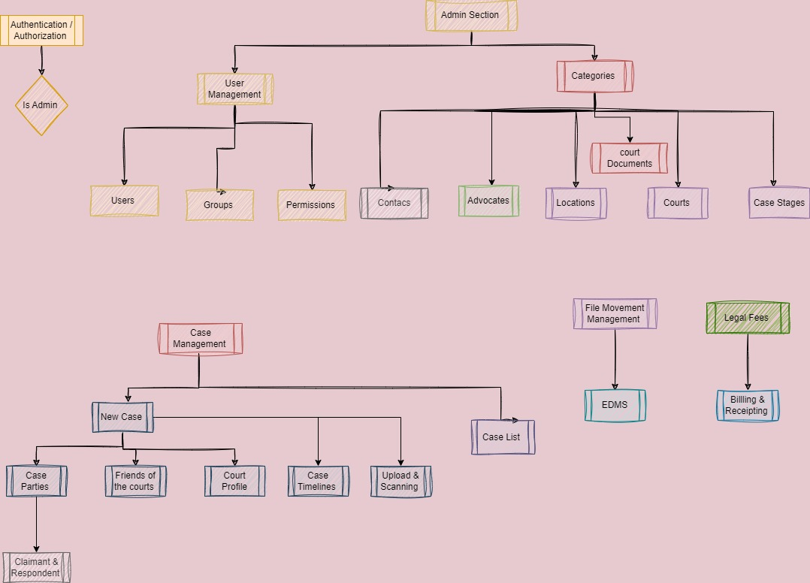

## General Description

### Product Perspective

The Case Management System is a web-based application that will be developed to provide a centralized platform for managing legal cases, case-related data, and legal fees. The system will be developed to integrate with other existing systems, including the Electronic Document Management System (EDMS) and the Customer Relationship Management (CRM) system.

The EDMS will be used to store files uploaded to the system, while the CRM system will be used to manage communication with customers and stakeholders. The system will also integrate with external systems, such as the court system, to enable users to track the movement of case files and obtain updates on the status of cases.

The product perspective will also involve identifying the different types of users and stakeholders who will interact with the system, including the Legal Unit of the Office of the Data Protection Commissioner, management, IT staff, and file archives staff. The system will be designed to meet the needs of these users by providing them with the necessary tools to create, manage, and view legal cases and related data.

Additionally, the system will be designed to be scalable and flexible to allow for future growth and expansion. As such, the product perspective will also involve considering the system's future requirements and the potential need for upgrades or modifications to meet the changing needs of users and stakeholders.

### Product Features

* Authentication & Authorization: Users are required to log in to the system using their unique credentials. The system has robust authentication and authorization features to ensure that only authorized users have access to the system and that they can only perform actions that they are authorized to perform.
* Case Management & Profiling: The system allows users to create, manage and view cases. Each case has a unique case number and is associated with a set of case-related data, such as the parties involved, the case status, and the court in which the case is being heard. The system also allows for the creation of case profiles that contain detailed information about the case and its history.
* Case Parties Profiling: The system allows for the creation of profiles for advocates and magistrates involved in the cases. These profiles contain information such as their contact details, qualifications, and case history.
* Court Profile: The system allows for the creation of profiles for courts involved in the cases. These profiles contain information such as the court's location, jurisdiction, and case history.
* Management Tracking of Files Movement: The system allows users to track the movement of case files within the court system. This feature provides real-time updates on the location of the case files and the status of the case.
* Administration of Legal Fees: The system allows for the administration of legal fees for cases. This feature facilitates the calculation of legal fees for each case and provides the ability to generate invoices for the fees.
* Reports: The system provides a set of predefined reports that can be generated based on user-specified criteria. The reports provide detailed information about cases, such as the status of cases, the number of cases pending, and the number of cases that have been closed. Additionally, the system allows users to create custom reports as well.

### User Characteristics

* The Case Management System is designed for use by the following groups of users:
* STAFF of Legal Unit of the ODPC: The system shall allow the legal unit staff to create, manage, and view cases, track the movement of case files, and administer legal fees. The system shall also provide predefined reports and data visualization features to enable users to interpret data easily.
* Management: The system shall provide management with access to reports and data visualization features to enable them to monitor the performance of the legal unit, including the number of cases pending and closed, legal fees generated, and other key performance indicators.
* IT: The system shall allow IT staff to manage the system, including system configuration, backups, and security.
* File Archives Staff: The system shall allow file archives staff to track the movement of case files within the court system.

### Constraints

The system is designed for use in a legal environment and is not intended for use in other industries.

The system's functionality is based on a set of assumptions about the legal process and may not be suitable for use in jurisdictions with different legal processes.

The system is not intended to provide legal advice and should not be used as a substitute for the advice of a qualified legal professional.

### Assumptions and Dependencies

The system assumes that users have a basic understanding of the legal process and legal terminology.

The system assumes that users will have access to the necessary equipment and infrastructure to use the system, including computers and internet access.

The system assumes that users will receive the necessary training and support to use the system effectively.

The system is designed with the assumption that users will maintain their data accuracy, completeness, and data security.

This project scope will ensure that the system can be designed, developed, tested and implemented within the constraints of time, budget and resources. It also sets the expectations for the system's functionality and the level of support that will be provided for its use..

## Specific Requirements

### Functional Requirements

#### Authentication and Authorization:

1.1 The system shall provide a login page for users to enter their unique credentials.

1.2 The system shall verify user credentials and grant access only to authorized users.

1.3 The system shall restrict users from performing actions they are not authorized to perform.

#### Case Management:

2.1 The system shall allow users to create, edit, and view cases.

2.2 Each case shall have a unique case number.

2.3 The system shall allow users to associate case-related data, such as party’s involved, case status, and court.

2.4 The system shall allow users to create case profiles containing detailed case information and history.

#### Case Parties Profiling:

3.1 The system shall allow users to create profiles for advocates and magistrates involved in the cases.

3.2 The profiles shall contain information such as contact details, qualifications, and case history.

#### 

#### Court Profile:

4.1 The system shall allow users to create profiles for courts involved in the cases.

4.2 The profiles shall contain information such as the Case location, jurisdiction, and case history.

#### Management Tracking of Files Movement:

5.1 The system shall allow users to track the movement of case files within the court system.

5.2 The system shall provide real-time updates on the location of the case files and the status of the case.

#### Administration of Legal Fees:

6.1 The system shall allow users to administer legal fees for cases.

6.2 The system shall facilitate the calculation of legal fees for each case.

6.3 The system shall provide the ability to generate a legal fees report that can be attached to the relevant invoice.

#### Reports:

7.1 The system shall provide a set of predefined reports based on user-specified criteria.

7.2 The reports shall provide detailed information about cases, such as the status of cases, the number of cases pending, and the number of cases that have been closed.

7.3 The system shall allow users to create custom reports.

### Non-Functional Requirements

1. Security: The system shall use industry-standard encryption protocols to protect user data in transit and at rest.
2. Scalability: The system shall be able to handle a minimum of 100 concurrent users without performance degradation.
3. Usability: The system shall be easy to use and navigate, with clear instructions and error messages.
4. Compatibility: The system shall be compatible with the latest versions of commonly used web browsers and operating systems.
5. Maintainability: The system shall be designed to allow for easy maintenance and updates, with clear documentation and modular code architecture.
6. Data Backup and Recovery: The system shall have a backup and recovery plan in place to ensure that data is not lost in the event of system failure or data corruption.
7. Compliance: The system shall comply with all relevant laws and regulations, including data privacy laws and regulations.

### External Interface Requirements

External Interface Requirements specify how the system will interact and communicate with external systems. In this case, the system will integrate with two external systems: EDMS (Electronic Document Management System) and CRM (Customer Relationship Management) software.

The integration with the EDMS will allow the system to store files uploaded to the system. This means that the Case Management System will be able to retrieve and save files to the EDMS, ensuring that all case-related data and documents are stored securely and centrally.

On the other hand, the integration with the CRM software will enable the system to allow CRM users to approve access to files. This means that users who need access to case files will need to request approval from the CRM system where the files are physical in nature. Once approved, the user will be able to access the relevant files from the Case Management System. This ensures that access to sensitive case files is tightly controlled and restricted only to authorized users.

Overall, the integration with the EDMS and CRM will enhance the functionality and usability of the Case Management System, making it more efficient, secure, and user-friendly.

### Design Constraints

### The system is designed for use in a legal environment and is not intended for use in other industries.

### The system's functionality is based on a set of assumptions about the legal process and may not be suitable for use in jurisdictions with different legal processes.

### The system is not intended to provide legal advice and should not be used as a substitute for the advice of a qualified legal professional.

### 

## Appendices

### Glossary

* CMS: Case Management System
* ODPC: Office of the Data Protection Commissioner
* EDMS: Electronic Document Management System
* CRM: Customer Relationship Management system
* UI: User Interface
* UX: User Experience
* API: Application Programming Interface
* SSL: Secure Socket Layer
* IP: Internet Protocol
* URL: Uniform Resource Locator
* SQL: Structured Query Language
* LDAP: Lightweight Directory Access Protocol
* SSO: Single Sign-On
* HTML: Hypertext Markup Language
* CSS: Cascading Style Sheets
* JS: JavaScript
* PDF: Portable Document Format
* CSV: Comma-Separated Values
* JSON: JavaScript Object Notation
* XML: Extensible Mark-up Language
* MVC: Model-View-Controller

### Use Case Diagrams

A use case diagram is a graphical representation of the interactions between actors (users, systems, or other entities) and a system or application. It illustrates the functional requirements of the system in a simplified way, using actors and use cases to represent the system's behavior

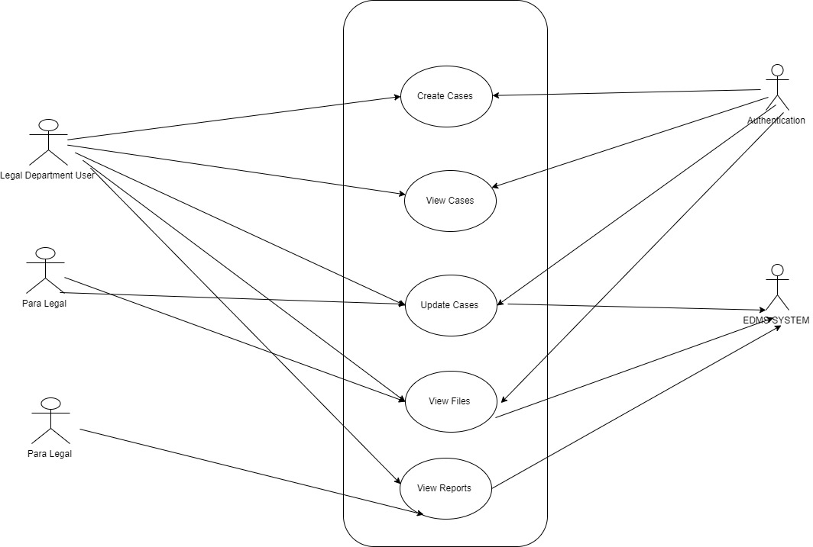

### Activity Diagrams

An activity diagram is a graphical representation of a business process or workflow, showing the sequence of activities, tasks, and decisions needed to complete the process. It is a type of flowchart that illustrates the steps and decision points in a process, and how they relate to each other.

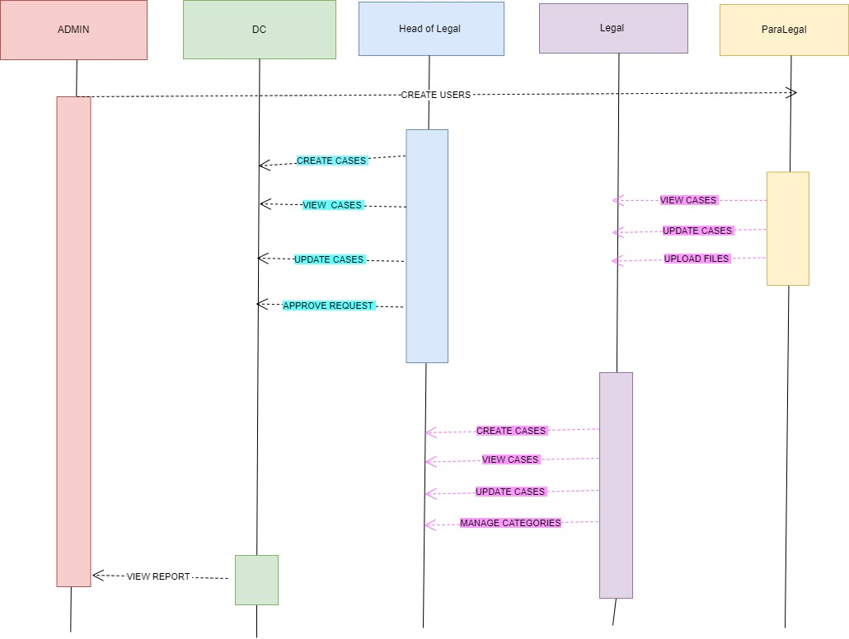

### Sequence Diagrams

A sequence diagram is a type of interaction diagram that shows how objects interact in a particular scenario or sequence of events. It illustrates the interactions between objects in a chronological order

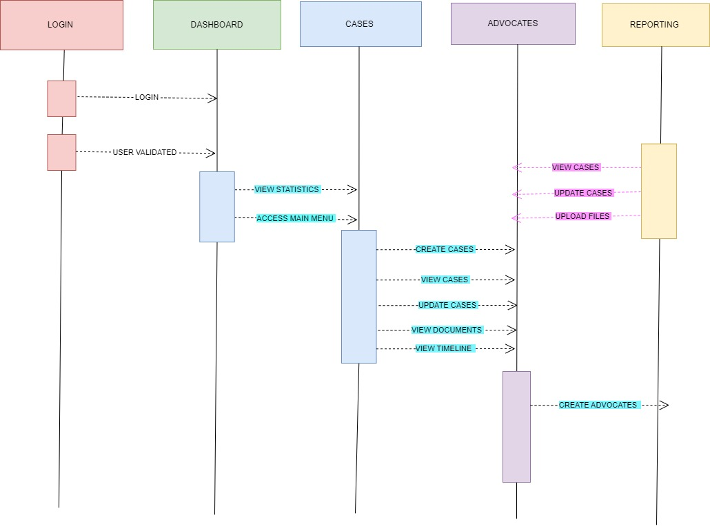

### System Architecture Diagrams

